## Introduction

In this project I am developing a web-based game application that will be made using HTML, CSS and JavaScript. I am creating this report alongside the game which will display the plan for the project of the COMP1004 module. This project will follow the software development lifecycle to ensure that the development of the game will be structured. This means that I will be able to plan and manage my time more efficiently, resulting in a more successful completed game that will meet the requirements and deadlines.

This report shows the steps I have taken to complete this game, highlighting the issues that may have had an impact on time when designing and developing the game, and any concerns that I have discovered, which may be legal social and ethical, throughout the project. It will also present the requirements that I will follow to ensure the success of the game, which will also help with the development of the architecture. I will finish the project by talking about the sprints and how they helped with the planning of tasks for each week. An evaluation will follow, explaining how the project went and whether it was a success.

## Software Development Lifecycle

For this project, the scrum methodology has been implemented, ensuring regular sprints every two weeks. Each sprint has been meticulously planned, with tasks following the product backlog. This approach allowed for dynamic response to setbacks and new discoveries, ensuring that the project remained on track.

These are the software development life cycle steps:

* Planning
* Requirements Analysis
* Design
* Implementation
* Testing
* Deployment
* Maintenance

Following these steps ensures that the result of the project is completed by the deadline, with any issues that may arise is tackled much more efficiently. It could take much longer to complete a project and many unexpected issues could occur if this structure is not followed.

The main items that are featured in the scrum model are:

Product backlog

This is used as a plan for the product to show the priorities of each task that will need to be completed. This is to ensure that the main tasks are being completed first to get the overall functionality and then any other added details that might want to be included can be added at the end if there is enough time. This is a very useful document that helps keep the user on track if it is followed in order of the tasks to be completed.

Sprint backlog

The start of the sprint will display the tasks that need to be taken place for the next two weeks and what items of the project will be worked on. At the end of each sprint, the project owner will decide which items have been completed. The completed software will also be displayed. Throughout the project there will be daily scrum meetings which will highlight the work completed on the previous day and the work to be completed the following day.

User stories

The user stories are featured in the product backlog but are not put in order of priority. They are used to show what the user actually wants from the game. These are especially important to follow because the users will be playing the game and therefore implementing what they would like will overall result in a successful game.

## Design Document

**Executive Summary**

Game Concept

The player has to get the ball in the hole in as little as shots as possible. There will be 9 levels or “holes” that the player will compete in. At the end of the 9 holes the player will be able to see the leaderboard which will display the overall score and how many minutes were spent playing.

Genre

The genre of the game will be an online retro sports game.

Target Audience

The game will be targeted toward people who play golf. Males will make up the majority of audience that will enjoy this game as they are the majority of golf players. It will be aimed at ages 18-24 as people in this age category will be more likely to play games and golf.

Project Scope

The requirements that have been asked are to track the players username, score, level and minutes spent playing, which will be stored in a flat file using json. There needs to be some custom art for the game pages and the game needs to be fully functioning.

**Gameplay**

Objectives

The objective of the game is to get the ball in the hole in as little goes as possible. The players with the least scores will be displayed on the top 10 leaderboard.

Game progressions

The player will move onto a different level each time the previous level has been completed. I will be implementing 9 levels for the player to complete.

In game GUI

The home page will feature buttons which will allow the player to start the game, see the controls, open the leaderboard and exit the game. When the game has started, there will be on screen buttons which will allow the user to set the angle and power of the shot and there will be a button to click to hit the ball.

**Mechanics**

Rules

The player will only be allowed a maximum of 10 shots before automatically being moved onto the next level.

The ball cannot leave the game canvas.

If the ball gets put in the whole the player will move onto the next level. After the 9th level the player will see their score and hope to be on the leaderboard.

Physics

The will have similar physics to games like 8 ball pool and raft wars. The player will aim using an arrow and drag down a bar to get the power of the shot. For example, If the player aimed upwards and did full power, the shot would go very high and not far.

**Game Elements**

Characters

Customizable characters will be implemented in the game. Players will be able to choose from a different range of characters that I will create myself and a range of colors for the ball. I will implement over 10 characters that will each have a pixel theme.

Leaderboard

During each level the score will be displayed on the top of the screen. At the end of a the game there will be a leaderboard showing the score for each of the levels and the overall total score. There will also be a column for the amount of minutes spent player. I want to implement the leaderboard so that the data for the player will save each time it is played so that the player can see the previous progress.

Level Design

Each level will have a different theme to it, for example one level may have an underwater theme and next will be set in the space. This will keep the user more engaged in the levels and always wondering what he next level theme will be.

**Assets**

When gathering my assets, I will consider the legal, social and ethical issues. This means that any assets I gather will be free to use and follow the copyright, designs and patents act 1998.

Music

Each level will have different music that will be related to its theme. This will give the user the full experience of the levels theme. There will also be music that will be playing on the home screen and once the game has finished.

Sound Effects

Every time the player hits the ball a different sound effect will play depending on how hard the ball has been hit. If it is hit gently then there will be a soft sound, but if it is hit with more power there will be a hard sound.

2d/3d models

I will be implementing 2d character models which I will be creating myself. The background will be a 2d model that I will get from an assets store. If I cannot find some backgrounds, I will be creating them myself. The ball will also be 2d and implemented from an asset store.

### Project Vision and Background

RetroGolf’s vision is to deliver a playable SPA web game that will give off a mini golf experience, combining aiming mechanics from games like raft wars to 8ballpool. Players will find themselves in a nostalgic journey, competing in nine unique levels to get the lowest scores possible. The game will be engaging and competitive fun, with features of customizable characters and golf equipment and also a leaderboard to keep track of your score and minutes spent playing.

The aim for Retro Golf has emerged from a passion for nostalgic games and a desire to relive the joy of classic mini golf into the modern age. The inspiration has come from timeless games like raft wars to 8 ball pool. The development of Retro Golf has not only been fueled by the love for gaming, but also by the ambition to create a vibrant online community. Within this community, Players will be able to connect, compete and share their experiences.

Through my extensive research and analysis, I have discovered an expanding audience for web based games. Furthermore, I have identified that as the gaming industry continues to develop, there are very few mini golf games that not only offer immersive gameplay mechanics, but also focus on the sentimental value of retro aesthetics. With an increasing demand for engaging online games, RetroGolf aims to provide players with a nostalgic journey whilst introducing fresh and exciting elements into traditional mini golf gameplay.

### Sprints

Sprint 1 – 29/11/23

Tasks:

- Create Game Design Document

- Define functional requirements and create user stories for the Product backlog

- Research potential issues

No issues arose during this sprint. The meeting was successful; the game idea was finalized, and both the Game Design Document (GDD) and product backlog will be completed before the next sprint. Research on potential issues throughout the project will facilitate easier handling if they arise.

Sprint 2 – 13/12/23

Tasks:

- Develop UML diagrams

- Create initial prototype for home page

No issues were encountered. The meeting was successful, with the completion of the GDD and product backlog enabling more effective task planning to meet deadlines. Challenges were researched and documented for easier resolution. Priority was given to completing the initial prototype to showcase the game concept.

Sprint 3 – 31/1/24

Tasks:

- Develop game prototype for ball and hole collision

- Integrate level scoring onto canvas

Issue:

- Home page functionality

The meeting reviewed the basic homepage, which had been created, allowing users to access the game page. Initial UML diagrams were completed. The project progressed as planned, though challenges in creating the game may arise, necessitating preparedness to address them.

Sprint 4 – 14/2/24

Tasks:

- Improve ball movement efficiency

- Implement water and sand objects

- Establish scoring functionality

Issues:

- Difficulty implementing ball movement without a physics engine

- Non-functioning level scoring

The meeting discussed setbacks in ball movement and scoring functionality. Though imperfect, the ball could collide with the hole and reset. Plans to address these issues were reviewed for implementation in the next sprint.

Sprint 5 – 28/2/24

Tasks:

- Implement ball and obstacle collisions

- Create canvas borders

- Randomize sand and water placement

- Introduce additional challenge elements

Issues:

- Ball exiting canvas

- Ineffective collision with sand and water

- Static placement of sand and water

The meeting addressed numerous issues, proposing solutions such as a dragging mechanism for the ball, randomized obstacle spawns, and canvas barriers. Despite deviating from the plan, resolving these issues would restore project progress.

Sprint 6 – 13/3/24

Tasks:

- Implement leaderboard using JSON

- Create options page displaying controls

- Add sound effects

- Integrate exit/restart button

No issues were raised in this sprint. The meeting concluded with successful implementation of previously challenging features, with minor details remaining to be added before the next sprint.

Sprint 7 – 27/3/24

Tasks:

- Finalize details and enhancements

- Add bonus features like colour picker and time limit

- Conduct thorough testing

No issues arose during this sprint. The meeting confirmed the completion of the game, with some additional features added beyond the initial plan to enhance user experience.

Sprint 8 – 10/4/24

Tasks:

- No specific tasks planned

No issues were raised in this sprint. The meeting celebrated the successful completion of the project, attributing it to dedication and feedback from previous meetings.

### Product Backlog

### User stories and Associated Use Case Scenarios

|  |  |
| --- | --- |
| Name | View Options Menu |
| Short Description | User clicks on the options button. |
| page9image35689536Precondition | The game application is launched and running. |
| Post Condition | Options menu is displayed to the user. |
| Error Situations | Player enters wrong input |
| System state in the event of an error | None |
| page9image36638272Actors | User |
| page9image36649984Triggers | User clicks on the options button. |
| Standard Process | 1. User clicks on the options button. 2. Options menu is displayed. |
| page9image36442432  Alternative Process | None |

|  |  |
| --- | --- |
| Name | Start or Quit Game |
| Short Description | User chooses to either start playing the game or quit the game. |
| page9image35689536Precondition | The game application is launched and running. |
| Post Condition | Game starts or exits based on user choice. |
| Error Situations | Player enters wrong input |
| System state in the event of an error | None |
| page9image36638272Actors | User |
| page9image36649984Triggers | User clicks on either "Start" or "Quit Game" button. |
| Standard Process | 1. User clicks on the "Start" button to begin playing the game. 2. Game starts. OR 1. User clicks on the "Quit Game" button. 2. Alert asks user to quit 3. User clicks yes and quits |
| page9image36442432  Alternative Process | None |

|  |  |
| --- | --- |
| Name | View Name, Score, and Minutes Spent Playing |
| Short Description | User views their name, score, and the amount of time spent playing the game. |
| page9image35689536Precondition | The user has completed the game and accessed the leaderboard |
| Post Condition | User's name, score, and time spent playing are displayed on the leaderboard |
| Error Situations | None |
| System state in the event of an error | None |
| page9image36638272Actors | User |
| page9image36649984Triggers | User accesses the leaderboard after finishing the game |
| Standard Process | 1. User completes the game 2. User gets sent to the leaderboard screen |
| page9image36442432  Alternative Process | 1.User accesses the leaderboard through the menu |

|  |  |
| --- | --- |
| Name | Add Name and Score to Leaderboard |
| Short Description | User adds their name and score to the leaderboard after completing a level. |
| page9image35689536Precondition | User completes game and enters name |
| Post Condition | User's name and score are added to the leaderboard. |
| Error Situations | None |
| System state in the event of an error | None |
| page9image36638272Actors | User |
| page9image36649984Triggers | User completes the game |
| Standard Process | 1. User completes the game. 2. User is prompted to enter their name. 3. User submits their name. 4. Name and score are added to the leaderboard. |
| page9image36442432Alternative Process | 1.User accesses the leaderboard through the menu |

|  |  |
| --- | --- |
| Name | View Level and Total Score |
| Short Description | User views the current level and total score. |
| page9image35689536Precondition | User is playing the game. |
| Post Condition | User's current level and total score are displayed. |
| Error Situations | None |
| System state in the event of an error | None |
| page9image36638272Actors | User |
| page9image36649984Triggers | User is playing the game. |
| Standard Process | 1. User completes a level 2. Score for the previous level is added to the top of the screen |
| page9image36442432Alternative Process | None |

|  |  |
| --- | --- |
| Name | Customize the Ball |
| Short Description | User customizes the appearance of the game ball. |
| page9image35689536Precondition | User accesses the options |
| Post Condition | Ball appearance is customized according to user preferences. |
| Error Situations | None |
| System state in the event of an error | None |
| page9image36638272Actors | User |
| page9image36649984Triggers | User changes the ball colour and presses save |
| Standard Process | 1. User navigates to the customization menu. 2. User selects colour of ball 3. User clicks save 4. The ball colour is now changed |
| page9image36442432Alternative Process |  |

|  |  |
| --- | --- |
| Name | Collide with Objects |
| Short Description | User's ball collides with objects within the game environment. |
| page9image35689536Precondition | User is playing the game. |
| Post Condition | Game reacts to the collision event. |
| Error Situations | None |
| System state in the event of an error | None |
| page9image36638272Actors | User |
| page9image36649984Triggers | User's ball collides with objects in the game environment. |
| Standard Process | 1. User hits the ball into one of the objects 2. The game reacts to the collision depending on what object is hit |
| page9image36442432Alternative Process | None |

### Architecture

Package Diagram

Class Diagram

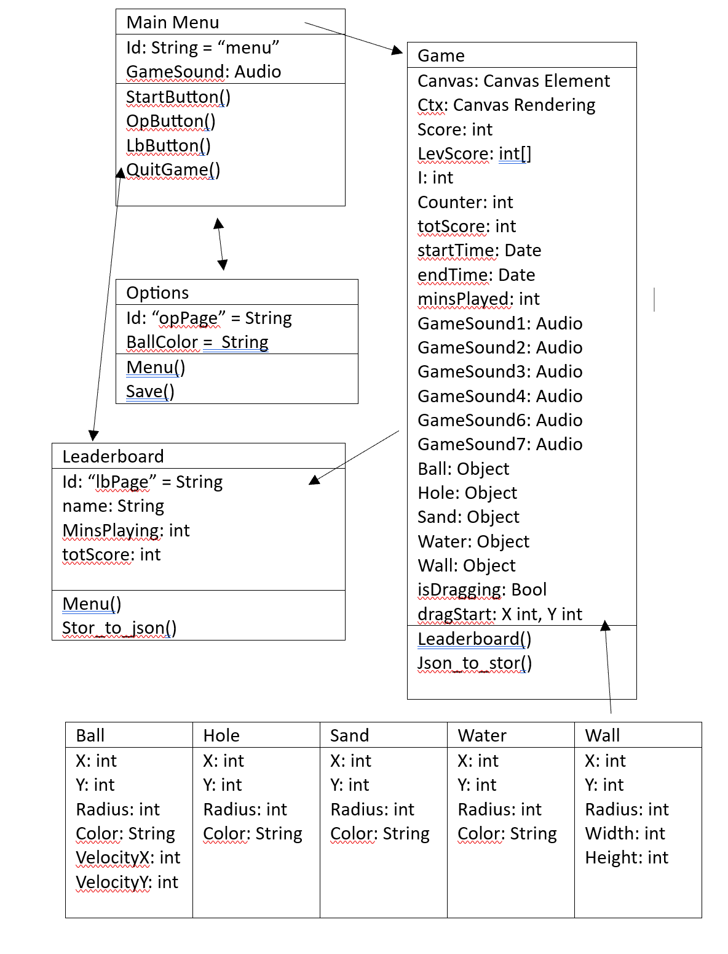

Sequence Diagram

### Sitemap

### Wireframes

### Noted issues and constraints

Even with the successful outcome of the project, there were still many obstacles faced throughout. I had researched some of the issues that could arise at the start of the project which helped with overcoming them easier when they did appear.

The sprints and the kanban board helped me outline and any issues that had appeared and visually showed me what I needed to prioritize first to get tasks completed before the deadline. I had many issues with the functionality of the game not working correctly and I had to figure out different ways of implementing the different features that I wanted to include. This means that my finished game does not fully match the designs that I had created before I started to make the game because I had to find different ways of implementing things. The main issue that set me back was the ball shooting mechanic. This was completely different to how I had visioned at the start of the project, but I had expected it to cause an issue due to my research beforehand. There were many other issues as well and the best way that I found to overcome them was trial and error. I had to put more effort into figuring out problems and spent a lot of time trialling different methods until I got an outcome that I was happy with. This ultimately has shown me that not everything will stick to the plan but being prepared for that to happen will result in success.

In addition to the technical challenges encountered during the development of the game, there were also legal, social, and ethical considerations that needed to be addressed.

From a legal perspective, I ensured that I complied with the Copyright, Designs and Patents Act 1988. To ensure this, all the graphics, music and other assets used in the game were properly licensed to avoid any potential copyright and legal issues. Furthermore, I had to pay attention to the Data Protection Act 2018, which is used to safeguard any personal information that I collected through the game (such as leaderboard name).

When considering the social issues, I had to carefully decide on the games content and themes to ensure that they are appropriate for all of the players. This meant that I needed to avoid any content that could be perceived as discriminatory or offensive. Additionally, I had made the writing as big as possible and added a customizable feature on the ball colour to consider people with visual impairments.

For the ethical issues, I had to ensure that I provided honesty with the users of the game. This means that making any in-game purchases, advertising or data collection clear to the users, however I had not included any of this within the game. Moreover, the game does not include any violence and is family friendly for anyone to be able to play.

### Github repo link

<https://github.com/Mattrfish/Comp-1004---Computing-Practice.git>

### References